

**Tribhuvan University**

**Faculty of Humanities and Social Sciences**

**“Thaekedar: Construction Contact Management System”**

**A PROJECT REPORT**

**Submitted to**

**Department of Bachelor in Computer Application**

**Kathmandu Business Campus**

***In partial fulfillment of the requirements for the Bachelors in Computer Application***

Submitted by

Bivek Raj Shakya Sandesh Rana Magar

BCA 4th Semester BCA 4th Semester

University SN:6-2-1219-7-2021 University SN: 6-2-1219-29-2021

Roll No:7 Roll No: 29

Under the Supervision of

**Binod Thapa**



**Tribhuvan University**

**Faculty of Humanities and Social Sciences**

**Kathmandu Business Campus**

**Banasthali , Balaju**

**Supervisor’s Recommendation**

I hereby recommend that this project prepared under my supervision by **Bivek Raj Shakya( reg no:6-2-1219-7-2021)** and **Sandesh Rana Magar(reg no:6-2-1219-29-2021)** entitled **“Thaekedar: Construction Contact Management System”** in the Partial Fulfillment of requirement for the degree of Bachelor in Computer Application is recommended for that final evaluation.

Binod Thapa

Project Supervisor

BCA Department

Kathmandu Business Campus



**Tribhuvan University**

**Faculty of Humanities and Social Sciences**

**Kathmandu Business Campus**

**LETTER OF APPROVAL**

This is to certify that this project prepared by **Bivek Raj Shakya** and **Sandesh Rana Magar** entitled “**Thaekedar: Construction Contact Management System”** in partial fulfillment of the requirements for the degree of Bachelor in Computer Application has been evaluated. In our opinion it is satisfactory in the scope and quality as a project for the required degree.

Binod Thapa Ram Prasad Subedi

Supervisor Program Coordinator

BCA Department Kathmandu Business Campus

Kathmandu Business Campus

Internal Examiner External Examiner

**ABSTRACT**

The Construction Contact Management System, known as "Thaekedar" offers a straightforward solution for individuals seeking reliable agencies and professionals for their construction projects. In today’s world, contact has become one of the most essential and expensive assets. This system will help people who has hard finding contacts of a reliable agencies or peoples to work with while in the process of building their house excluding third party involvement it will provide direct contacts of preferred agencies, peoples, suppliers, etc. It will be able to save time and money. The system is implemented using web-based technologies which include CSS, JS, HTML, MySQL, PHP and runs on any Web Browser. In Thaekedar an Agency, Interior Designer, Architect, Engineer, Supplier can add contacts after admin approval and any users can view, rate, comment the contact of any type. This provides and build trust among the contacts. User can compare and choose their preferred contacts among different contact presented in the website. User can search and choose contacts that are near their location.

**ACKNOWLEDGEMENT**

We would like to express our special thanks of gratitude to our supervisor **Mr. Binod Thapa** who gave us the golden opportunity to do this wonderful project on the topic of ‘**Thaekedar: Construction Contact Management System’**, who also helped us in doing a lot of research and we came to know about so many new tools and technologies.

We would like to express my special gratitude and thanks to our BCA Program Coordinator **Mr. Ram Prasad Subedi** for his support and help for our personnel development and mainly for the completion of this Project

We are highly indebted to Kathmandu Business Campus for their guidance and constant supervision as well as for providing necessary information regarding the Project and support in the completion.

We would also like to express my gratitude towards library and member of Kathmandu Business Campus for their kind co-operation and encouragement which help us in completion of this Project.

We would also like to thank our parents and friends who helped us a lot in finalizing this project within the limited time frame.

In the end, we would also like to thank Tribhuvan University for giving us this opportunity via the course of Computer Application to help us understand the project ethics at this early stage and helped us to evaluate my knowledge and expand it a little more.

Yours sincerely,

Bivek Raj Shakya

Sandesh Rana Magar

**LIST OF ABBREVIATIONS**

CSS Cascading Style Sheet

CRUD Create, Read, Update and Delete

DFD Data Flow Diagram

ERD Entity Relationship Diagram

HTML Hyper Text Markup Language

HTTP Hyper Text Transfer Protocol

JS Java Script

MySQL Microsoft Server Structured Query Language

PHP Hypertext Preprocessor

# 

# TABLE OF CONTENTS

# Supervisor’s Recommendation………………………………………………………………...I

# Letter of Approval…………………………………………………………………………….II

# List of Abbreviations………………………………………………………………………...III

# List of Figures………………………………………………………………………………..VI

# List of Tables………………………………………………………………………………..VII

CHAPTER: 1 1

INTRODUCTION 1

1.1 Introduction 1

1.2 Problem Statement 1

1.3 Objectives 2

1.4 Scope and limitation 2

1.5 Report Organization 2

CHAPTER: 2 4

BACKGROUND STUDY AND LITERATURE REVIEW 4

2.1 Background Study 4

2.2 Literature review 4

CHAPTER: 3 6

SYSTEM ANALYSIS AND DESIGN 6

3.1 System Analysis 6

3.1.1 Requirement Identification 7

3.1.2. Feasibility Study 9

i Technical feasibility 9

ii Operational feasibility 9

iii Schedule feasibility 9

3.1.3 Data Modeling(ER-diagram) 10

3.1.4 Process Modeling (DFD) 12

3.2 System Design 13

3.2.1 Architectural Design 13

3.2.2 System flowchart 14

3.2.3 Database schema design 17

3.2.4 Interface Design (UI Interface) 17

CHAPTER: 4 22

4.1 Implementation 22

4.1.1 Tools Used (CASE tools, Programming language, Database platforms) 22

4.1.2 Implementation Details of Modules 23

CHAPTER: 5 25

CONCLUSION 25

5.1 Lesson Learnt/ Outcome 25

5.2 Conclusion 25

5.3 References 26

# LIST OF FIGURES

Figure 3.1: Waterfall Methodology for Construction Contact Management System 6

Figure 3.2 : Use Case Diagram of Construction Contact Management System 8

Figure 3.3: Gantt chart for Construction Contact Management System 10

Figure 3.4: Entity Relational Diagram for Construction Contact Management System 11

Figure 3.5: level 0 DFD for Construction Contact Management System 12

Figure 3. 6: Level 1 DFD for Construction Contact Management System 13

Figure 3.7: Architectural Design of Construction Contact Management System 14

Figure 3.8: Flow chart of Construction Contact Management System for admin 15

Figure 3.9: Flow chart of Construction Contact Management System for user 16

Figure 3. 10: Database Schema Design of Construction Contact Management System 17

Figure 3.11 : Signup Page of Construction Contact Management System 18

Figure 3.12: Login page of Construction Contact Management System 18

Figure 3.13: Home page of Construction Contact Management System 19

Figure 3.14: Add contact page of Construction Contact Management System 20

Figure 3.15: Approve/Decline Page of Construction Contact Management System 21

Figure 3.16: Admin Login Page of Construction Contact Management System 21

# LIST OF TABLES

Table 3.1: Gantt chart Table for Construction Contact Management System…………...10

# CHAPTER: 1

# INTRODUCTION

## Introduction

An **“Thaekedar: Construction Contact Management System”** is a Website that helps to find the contacts of the preferred people while building their dream house. It efficiently provides the contacts of Agency, Interior designer, Architect, Engineer, Supplier after the quality control from the admin itself.

Thaekedar: Construction Contact Management System, as described helps you with free, reliable and fast contacts of the Construction network. This website/platform is a user based management system where user submits their contacts and admin approves/decline the contacts based on authenticity of the contacts.

Overall, Construction Contact Management System helps agency, interior designer, architect, engineer and supplier to get recognized and the users which can also be contact provider themselves get the contacts of required people while building their dream house and also they can rate, comment and add contacts after the quality control from the admin itself.

## Problem Statement

The construction industry faces significant challenges due to a lack of proper networking during the house-building process. Individuals often struggle to connect with the right professionals, such as architects and suppliers, leading to delays and inefficiencies. Moreover, third-party intermediaries often exploit this gap by charging huge amount of fees, leveraging their connections to secure higher profits. This not only inflates costs but also undermines the affordability and accessibility of construction services.

Additionally, collaborating with outsourced parties can prove to be an expensive and time-consuming endeavor, further complicating the construction process. These issues underscore the urgent need for a solution that streamlines networking which enhances the efficiency of house-building process.

## Objectives

The main objective of this project is to help individuals get the contacts of reliable contractors while building house.

* + To develop a platform where users get’s the contacts to avoid time consuming process working with people who outsources the Construction process.

## Scope and limitation

1. **Scope**
   * 1. Users can easily connect with agency, architect, interior designer, engineer, supplier.
     2. It reduces time and manpower by removing middle man and reduces commission.
2. **Limitation**
3. It doesn’t facilitate with buying and selling of houses and land.
4. It doesn’t include messaging service or direct communication medium.

## Report Organization

**Introduction**

This chapter deals with the introduction of the system with its objectives and limitations along with the reason why the system is made.

**Background Study and Literature Review**

This chapter summarizes the work that has been carried out in the field of data mining and also describes the features about some existing applications related to the employee leave management system.

**System Analysis and Design**

This chapter focuses on the different requirement of the system, which describes about the functional, non-functional, feasibility analysis, Entity Relational diagram, Data Flow Diagram, design of the system with system architecture, database schema, and interface design.

**Implementation and Testing**

This chapter emphasizes tools used in system development, implementing details and result of test performed.

**Conclusion and Future Recommendation**

This chapter highlights brief summary of lesson learnt, outcome and conclusion of the whole project and explain what have been done and what further improvements could be done.

# CHAPTER: 2

# BACKGROUND STUDY AND LITERATURE REVIEW

## Background Study

Our investigation into dalaydai.com, a prominent real estate platform, has revealed crucial insights shaping our project's direction. After asking the Founder of dalaydai.com we found that they has an average visitor of 12,000 per month and when it comes to feature of adding agencies, supplier their metrics where low and only 10% from the overall visitor per month visit the page which has the feature we are building. This underscores the need for targeted enhancements to optimize user interaction and satisfaction. We also found out that they used Django Framework, Vue JS, while we are using technologies like HTML, CSS and JavaScript and also PHP.

In summary, our background study shows the critical areas of user engagement, technological architecture, and market dynamics that inform our project's strategy. By addressing the identified gaps and focusing on Constructions only, we aim to deliver a solution that not only meets user needs but also stands out in the crowded Construction technology marketplace.

## Literature review

There are systems related to Thaekedar: Construction Contact Management System. We recently had different system which works as like this application.

From the different research and analysis, We found some of the related Websites. One of them being [dalaydai.com](https://dalaydai.com/) [1]. We found out that it have the multi-feature of adding houses to rent, buying and selling and there comes the feature of adding contacts of agencies and suppliers.

According to the source, Nepal Construction [2] has similar function like this application but only disadvantage being in the UI and UX where there is continuously running advertisement which becomes hard to navigate.

Our approach is simple and effective because it only connects people/agencies while he/she is building a house none other than that so we have niche down rather than doing it all. This will bring the quality to improve only on a Construction area.

# CHAPTER: 3

# SYSTEM ANALYSIS AND DESIGN

## System Analysis

System analysis is the most important phase in the development phase of Thaekedar: Construction Contact Management System. It helps in understanding the requirements, functionalities and how the system works in whole. It helps to ensure if the system is successfully implemented.

In Construction Contact Management System the system is designed with the series of process starting with the requirement analysis, system design, implementation and testing. In requirement analysis all the functional and non-functional requirement are analyzed and then system is designed using ER diagram, flow chart, etc. In implementation part we look over coding and development of the system. After the system is developed we do testing.

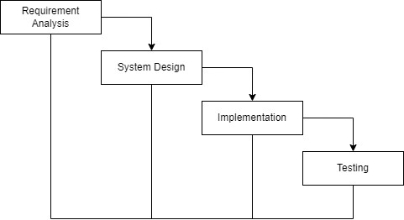

**Figure 3.1: Waterfall Methodology for Construction Contact Management System**

## Requirement Identification

Requirement identification are to be collected before the development of Thaekedar. This process involves identifying the functional and non-functional requirements of the system to ensure that it meets the needs of the users.

1. **Functional requirement**
   * + - * Users can sign-up and login to the system.
         * Users can apply for adding their contacts.
         * Admin can approve or decline user request for adding contact according to their authentic documentation.
         * Users can search contacts and give feedbacks like rating and comments.
         * Admin can manage contacts(update, remove and add contact).

**USECASE DIAGRAM**

In Thaekedar: Construction Contact Management System, there are two actors such Admin and Users where Admin can login, view contacts, approve/decline contact, manage contacts(add, update, remove) from the system. Likewise, user can login, add contacts, view contacts, rate and comment on contacts and logout from the system.

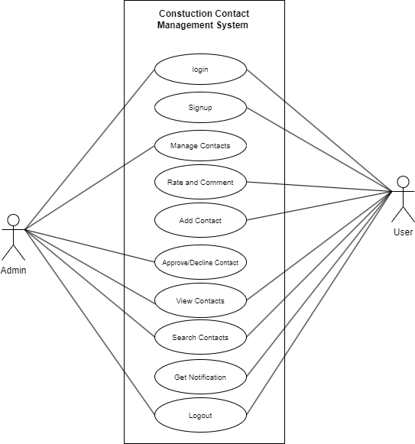

**Figure 3.2: Use Case Diagram of Thaekedar: Construction Contact Management System**

1. **Non-functional requirement**
2. **Security**

This system will be secure as the contacts of the users will only be shown as per their consent and their valuable document/license will not be visible to other users except admin so that admin can validate the authenticity of the contact.

1. **Performance**

This system is designed for better management between the user and admin in the process of adding contacts with optimum use of resources and saving time and effort.

1. **Reliability**

This system will be reliable for both the users and admin.

1. **Usability**

This system will be easy to use and navigate, with user-friendly interface.

## Feasibility Study

A feasibility study is a preliminary assessment of a proposed project plan to determine whether it is practically feasible. The purpose of a feasibility study is to identify potential risks, challenges, and opportunities associated with the project.

Following feasibility were studied before building the system to see if the system could be built with exact requirement in required time.

### Technical feasibility

This system uses existing technologies, software and hardware so there is no technological hurdle to build this system.

### Operational feasibility

This system uses simple technologies to design so it is easy to use and understand and it is user-friendly.

### Schedule feasibility

The system is completed within scheduled time and do not exceed the scheduled time.

**Table 3.1: Gantt chart Table for Thaekedar: Construction Contact Management System**

|  |  |
| --- | --- |
| **Task name** | **Duration** |
| Planning | 5 days |
| Analysis | 5 days |
| Design | 1 week |
| Coding | 8 week |
| Testing | 1 week |
| Documentation | 13 week |

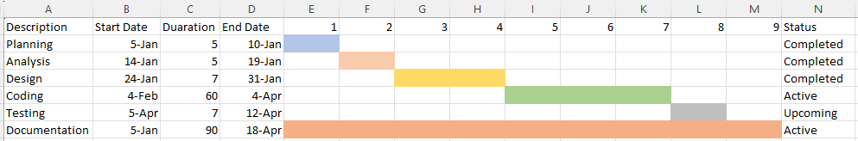

**Figure 3.3: Gantt chart for Thaekedar: Construction Contact Management System**

## Data Modeling(ER-diagram)

In Entity-Relationship diagram there are four entities named Users, Admin, Contacts,login. Users has attributes has attributes like user_id, password, email, name, user_type. Likewise Admin has same attributes as the users. Contacts has attributes like iglink, fblink, c_id, weblink, email, photo, phoneno, designation, document, name, location, status, description. Admin can manage(add, update,remove) contacts and approve/decline contacts. Users can apply for contact, rate, comment and view contacts.

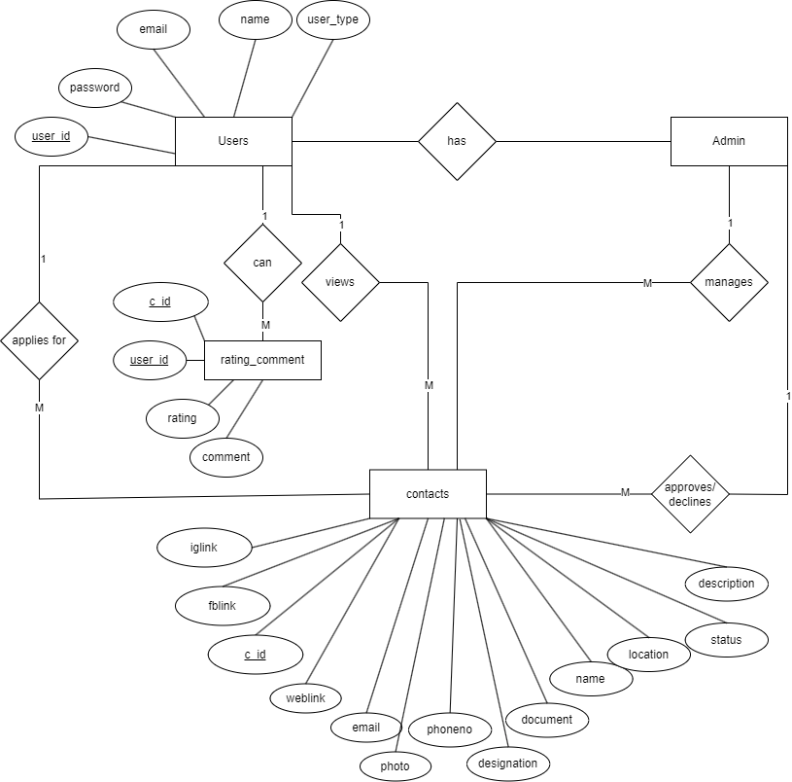

**Figure 3.4: Entity Relationship diagram for Thaekedar: Construction Contact Management System**

## Process Modeling (DFD)

Data Flow Diagram of Thaekedar: Construction Contact Management System consists of two levels of DFD context diagram and level one DFD. Both these levels are used for making data flow diagram of Thaekedar.

In context diagram, the users applies for contact for approval so that admin approve/decline the contact. Admin can Manage and get’s approval request while user can view, rate, comment and get approve/decline result.

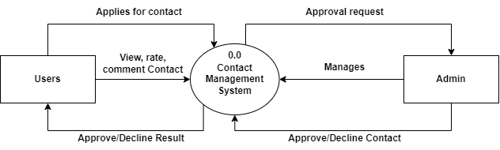

**Figure 3.5: level 0 DFD for Thaekedar: Construction Contact Management System**

In level 1 DFD, there are five processes where for register of users, process 1 is responsible, for login of user and admin, process 2 is responsible likewise process 3 is responsible for showing the appropriate contacts after the user searches. process 4 is responsible to manage contact after the user apply for contact admin get’s contact request and either admin approves or decline the contact. Process 5 is responsible for storing the rating and comment in database.

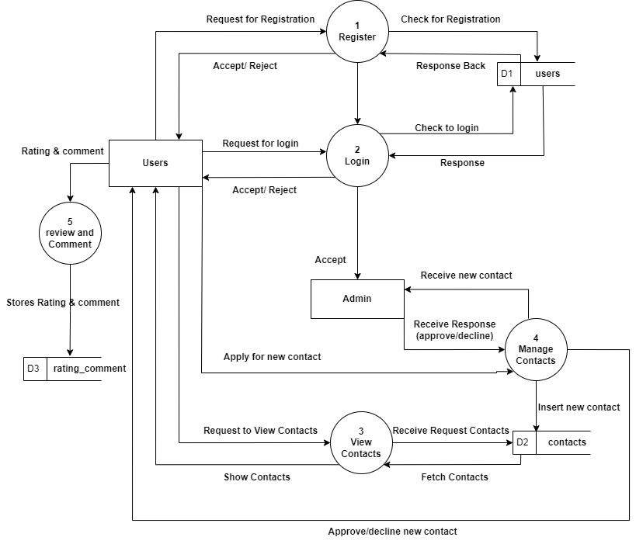

**Figure 3.6: level 1 DFD for Thaekedar: Construction Contact Management System**

## System Design

To realize the different functional requirement of the system in graphical form, different design diagram of the system has been prepared which are as follows:

### Architectural Design

For this system, three tier architecture is used which includes user interface, web server and database. In architectural design, basic structure of the system is show.

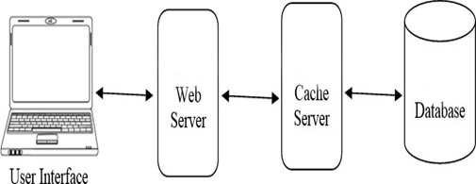

**Figure 3.7: Architectural Design of Thaekedar: Construction Contact Management System**

### System flowchart

The figure below is the flowchart of Thaekedar: Construction Contact Management System. Here, admin and users login. After login success, it redirects to dashboard in case of admin and index page in case of users. Admin views request of new contact. Admin can manage contacts and approve or decline the request. Users can view, rate and comment the contact and request to add contact. The admin do not need to register they can directly login the system and for the users, they have to register.

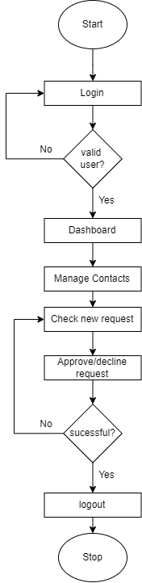**For Admin**

**Figure 3.8: Flowchart of Thaekedar: Construction Contact Management System for Admin**

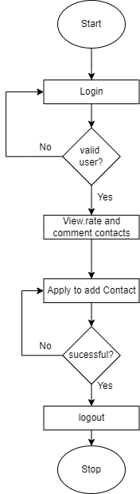**For Users**

**Figure 3.9: Flowchart of Thaekedar: Construction Contact Management System for Users**

### Database schema design

The figure below is the database schema design of Thaekedar: Construction Contact Management System. Database schema design is used to show basic structure of the system. In employee leave management system, there are five tables in the databases each of them have their own fields where their id is primary key and if that id is used in another table it becomes foreign key. There is data type of each entity and the foreign key in schema is represented by the arrow as shown in the diagram.

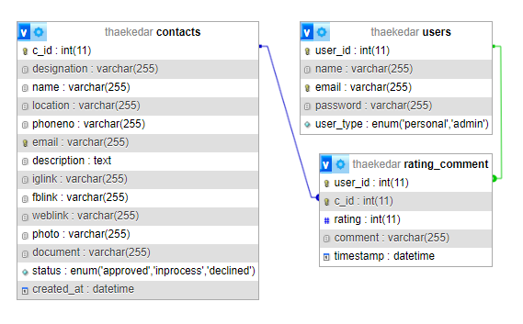

**Figure 3.10: Database Schema of Thaekedar: Construction Contact Management System**

### Interface Design (UI Interface)

Interface design is used to design how the Thaekedar: Construction Contact Management System looks like and this design is shown to user that how the system will look. And after finalizing the system development starts. The UI design of home page, login page, admin approve/decline page, signup page, add contact page, of Thaekedar: Construction Contact Management System are shown below:

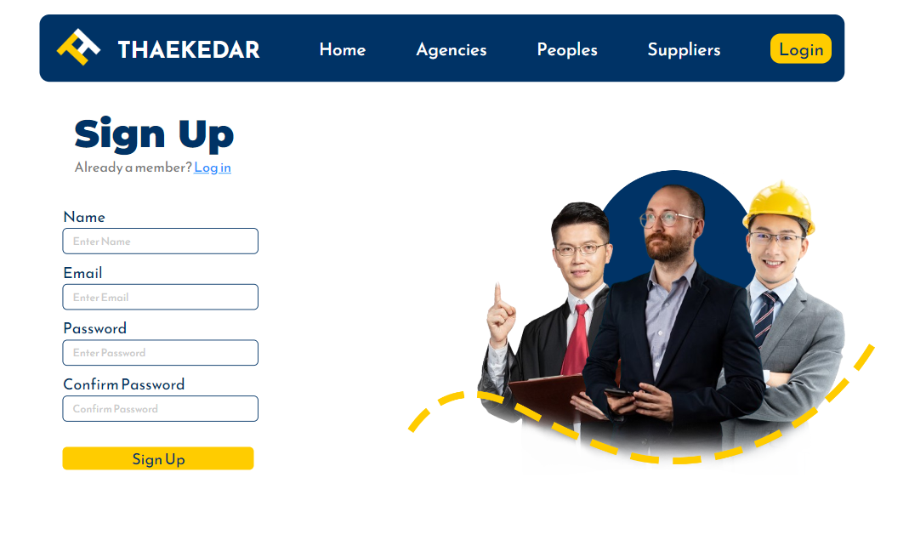

**Figure 3.11: Signup page of Thaekedar: Construction Contact Management System for users**

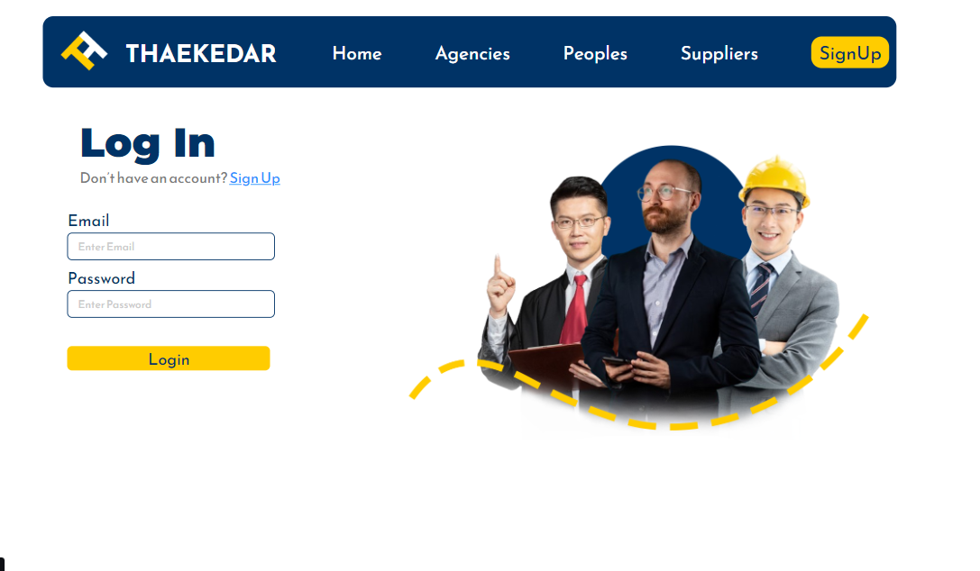

**Figure 3.12: login page of Thaekedar: Construction Contact Management System for users**



**Figure 3.13: Home page of Thaekedar: Construction Contact Management System for users**

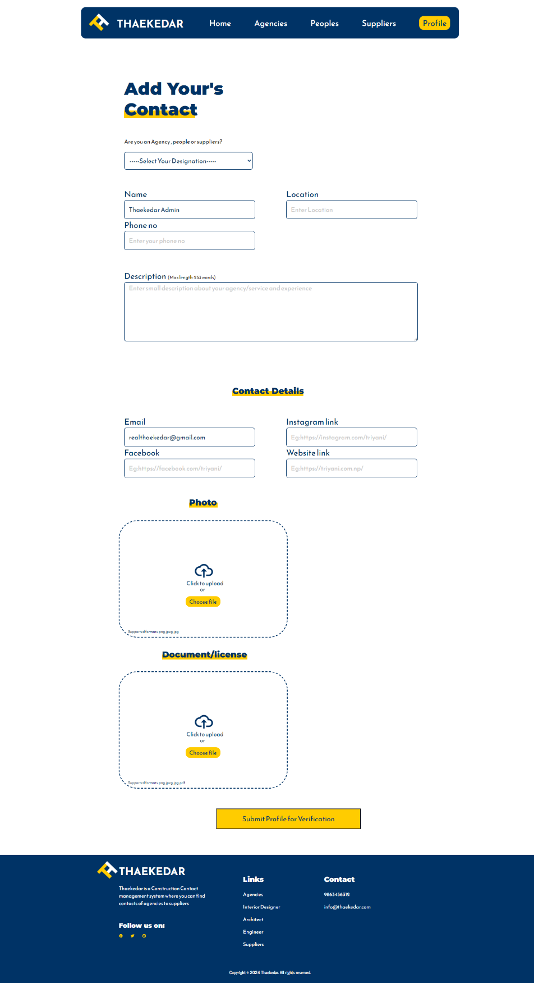

**Figure 3.14:Add Contact page of Thaekedar: Construction Contact Management System for users**

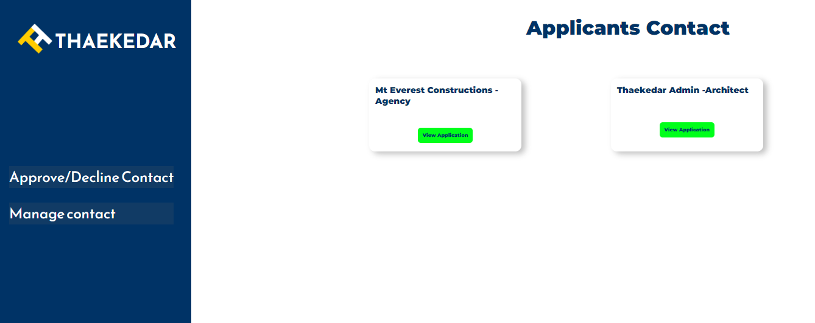

**Figure 3.15: approve/decline page of Thaekedar: Construction Contact Management System for admin**

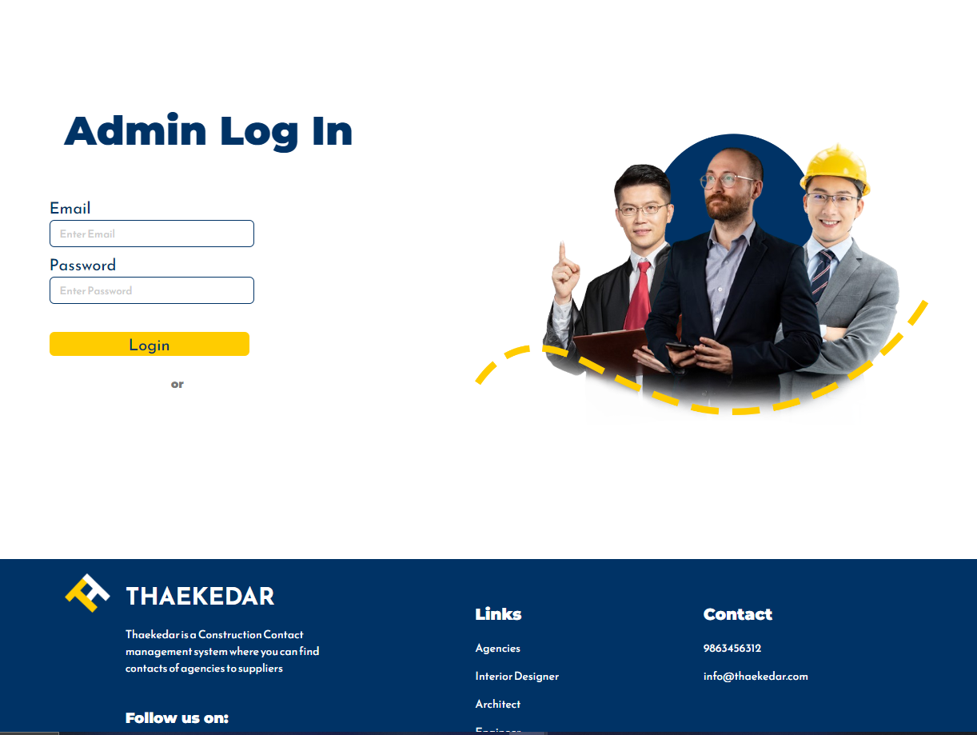

**Figure 3.16: admin login page of Thaekedar: Construction Contact Management System**

# CHAPTER: 4

**IMPLEMENTATION**

## Implementation

### Tools Used (CASE tools, Programming language, Database platforms)

Following are the tools and framework used for the accomplishment of this project:

* **Front end Tools:**
  + **Html:** HTML, which stands for Hyper Text Markup Language, is the standard markup language. It provides a structure and syntax for organizing and presenting content on the Internet. HTML uses a series of elements and tags to define the structure and formatting of a web document. Html is used for creating different webpage and sites. It is used to create and structure sections, headings, links, paragraphs using various tags and elements.
  + **CSS:** CSS, which stands for Cascading Style Sheets, is a styling language used to describe the presentation and appearance of a document written in HTML or XML. By using css, we can control the text color, font style, the spacing between paragraphs, sizing of columns, layout designs, and many more.
  + **JavaScript:** JavaScript is a high-level programming language primarily used for adding interactivity and dynamic behavior to websites. JavaScript is used for client-side validation and to make dynamic, interactive and responsive web pages. It is used to add dynamic behavior to the webpage and add special effects to the webpage.
* **Back end**
  + **PHP:** PHP is extensively used in website development due to its versatility and powerful features. PHP allows you to generate dynamic content on web pages based on user inputs, database queries, or other external data sources. It is used for server side scripting purpose to add connectivity to the database and also used to encrypt the data, validate the user data, confirm user to go to certain pages, login pages.
* **Server**
  + - **APACHE SERVER:** In employee leave management system, apache server is used to run php files and creating fast and dynamic web pages.
* **Database**
  + **MYSQL:** MySQL is a popular open-source relational database management system (RDBMS) that is commonly used in website design and development. It provides a reliable and scalable solution for storing, managing, and retrieving data for websites.MySQL allows you to create and manage databases to store website data efficiently. It is used for performing CRUD operation such as create, delete and update data from the database as requested by the user.
* **Documentation Tools** 
  + - **MS Office**: This is used for writing and editing the documentation of employee leave management system.
    - **Draw.io:** This is used to generate diagrams for system analysis and design of employee leave management system. Diagrams were created using this tool in order to save time since all components are available with drag and drop functions.

### Implementation Details of Modules

Different modules of this system are described as below:

**Admin module:**

* **Admin add/update/delete contacts**

In this module, admin can perform add, view, update and delete. The admin can add new contacts, can view all the contacts, can update all the information of contacts, and delete the information of any contacts.

* **Admin approve/declines contacts**

In this module Admin get’s the request from the user to add the contact where admin looks and decide whether to approve or to decline the contact after considering their document according to their authenticity.

**User module:**

* **User can apply to add contact**

Users can apply to add contact. They have to fill the given detail in add contact form and apply it which is received by the admin. They have to fill in the designation of contact and their details.

* **User can view, update and delete their contact**

User can view, update their contact information which will again be reviewed by admin. User can either view, update or delete their contact from the system.

* **User can rate and comment contacts**

User can rate and comment the contacts only if they are logged in.

**Login module:**

In login module, we have implemented two sub modules they are admin login and user login. Admin and User log into the system using their valid username and password.

# CHAPTER: 5

# CONCLUSION

## Lesson Learnt/ Outcome

Every project makes us to learn and gain the knowledge in different aspects. In the following project, we have learned lots of problem-solving skills and learn things like team work, finding the solution on our own, proper use of guidelines, communication and writing skills and management of team.

* **Teamwork**

Since this is a team project, it teaches how to work with group members and develop the system together. We have learned how to work with team and divide our task with each other and deal with the problem and error occurs in this system.

* **Problem Solving Skills**

From this project, we have learned lots of problem-solving skills and also learned to recognize different errors occur in this system and solve it.

* **Writing Skills**

We have learned how to prepare proposal and documentation related with project and also learned to use different case tools for use case diagram, schema diagram, data flow diagram, and ER- diagram and so on.

* **Manage time**

The most important lesson learnt was management of time according to the complexity of the system components i.e. know which components to prioritize.

## Conclusion

The Thaekedar: Construction Contact Management System has been developed to some extend with predefined objectives. This system fulfills some of the objectives that have been set to develop this system and this system can be viewed by admin and users with the provided login information. This system also provides easy and smooth user interface that can be used by non-technical users. This website makes easier for users to submit their contact. Likewise, it makes easier for admin to easily approve and decline the contacts.

## References

|  |  |
| --- | --- |
| [1] | M. K. Dhungana, Interviewee, *Dalay Dai.* [Interview]. 06 01 2024. |
| [2] | N. Construction, "Nepal Construction," 2015. [Online]. Available: http://nepalconstructions.com/. [Accessed 06 01 2024]. |